**TOP 10 CUSTOMERS OF ATLIQ HARWARE**

1. **SQL Query**

**with cte1 as (SELECT customer,**

**round(sum(net_sales)/1000000,2) as net_sales_mln**

**FROM net_sales**

**join dim_customer c**

**using(customer_code,market)**

**where ns.fiscal_year=2021**

**group by customer)**

**select *,**

**net_sales_mln*100/sum(net_sales_mln) over() as pct**

**from cte1**

**order by net_sales_mln desc**

**limit 10**

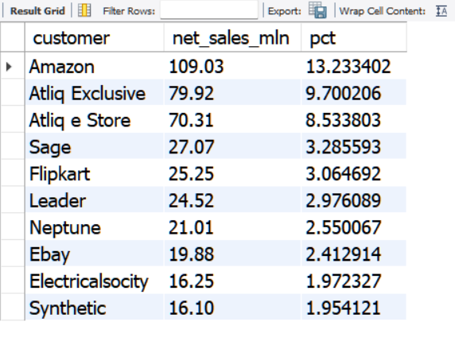

1. **View Query**

**CREATE**

**ALGORITHM = UNDEFINED**

**DEFINER = `root`@`localhost`**

**SQL SECURITY DEFINER**

**VIEW net_sales` AS**

**SELECT**

**`sales_postinv_discount`.`product_code` AS `product_code`,**

**`sales_postinv_discount`.`date` AS `date`,**

**`sales_postinv_discount`.`customer_code` AS `customer_code`,**

**`sales_postinv_discount`.`product` AS `product`,**

**`sales_postinv_discount`.`variant` AS `variant`,**

**`sales_postinv_discount`.`market` AS `market`,**

**`sales_postinv_discount`.`fiscal_year` AS `fiscal_year`,**

**`sales_postinv_discount`.`sold_quantity` AS `sold_quantity`,**

**`sales_postinv_discount`.`gross_price_total` AS `gross_price_total`,**

**`sales_postinv_discount`.`pre_invoice_discount_pct` AS `pre_invoice_discount_pct`,**

**`sales_postinv_discount`.`discounts_pct` AS `discounts_pct`,**

**`sales_postinv_discount`.`other_deductions_pct` AS `other_deductions_pct`,**

**`sales_postinv_discount`.`Net_invoice_sales` AS `Net_invoice_sales`,**

**`sales_postinv_discount`.`post_invoice_discount_pct` AS `post_invoice_discount_pct`,**

**((1 - `sales_postinv_discount`.`post_invoice_discount_pct`) * `sales_postinv_discount`.`Net_invoice_sales`) AS `net_sales`**

**FROM**

**`sales_postinv_discount`**